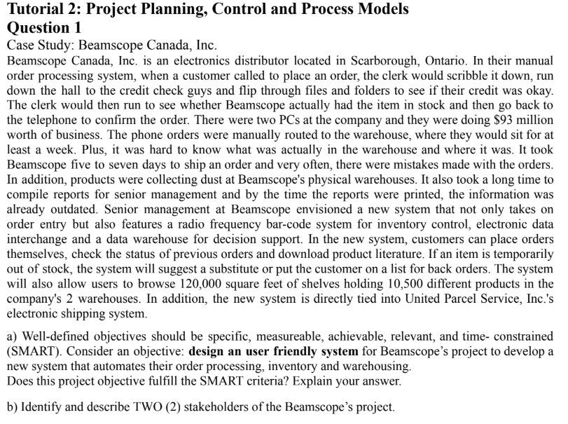
1a)
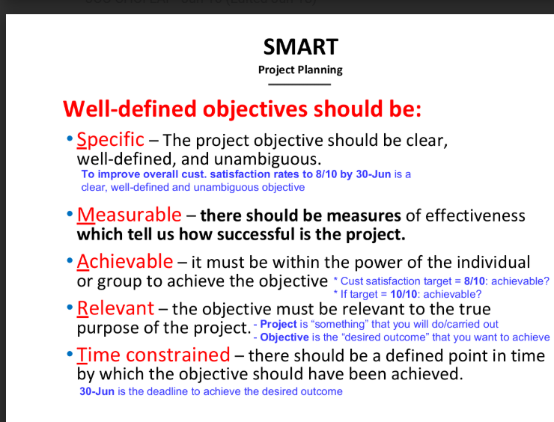

SMART criteria | Yes/No | Evaluation
Specific | No | Not specific enough. It doesn’t define what “user-friendly” means — e.g., easy navigation, intuitive interface or mobile compatibility
Measurable | No | Not measurable. There’s no way to measure how “user-friendly” the system is. A measurable goal would include user satisfaction scores or task completion times.
Achievable | Yes | Achieve,assuming the team has the right skills and resources
Relevant | Yes | Relevant to the project’s purpose— improving the efficiency of order processing and inventory control
Time-Constraint | No | The time-frame is not mentioned, there is no deadline for the development of the project.

Suggested Objective:
To design and implement a user-friendly automated order processing and inventory system within 6 months, which reduces order processing time by 70% and achieves at least 85% user satisfaction in post-deployment surveys.

1b)Stakeholders of Beamscope’s project are:

The senior management envisioned the new system as a project that features storing order entry, and radio frequency bar-code system for inventory control, electronic data interchange and a data warehouse for decision support.

The second stakeholder group would be customers who request for the system’s ability to place orders, check previous order statuses, and download product literature.

Other acceptable answers :
Clerk (line 2 in case study);
United Parcel Service Company (2nd last line in case study)

Team 3
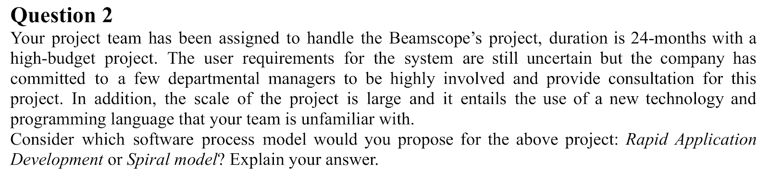

Propose the Spiral Model for the Beamscope’s project.
1.Uncertain Requirements:
Since the user requirements are still unclear, the Spiral Model is suitable because it supports iterative refinement through repeated cycles. Each iteration allows for gathering feedback and evolving the requirements, reducing the risk of misunderstanding user needs.
2. Large-Scale & High-Budget Project:
The Spiral Model is designed for complex and high-risk projects. It provides strong risk management mechanisms through each phase (planning, risk analysis, engineering, and evaluation), making it ideal for large and expensive projects where failure is costly.
3. New Technology & Language:
Because the team is unfamiliar with the technology and language, the risk is high. Spiral allows for early identification and mitigation of technical risks by incorporating prototyping and feasibility studies into each iteration.
4. Long Duration (24 months):
The extended timeline supports the Spiral Model's need for multiple iterative cycles. This ensures continuous improvement and risk assessment throughout the project.
5. Active Stakeholder Involvement:
Departmental managers are involved in consultations, which aligns with the evaluation phase of Spiral where continuous stakeholder feedback is integrated into the process.

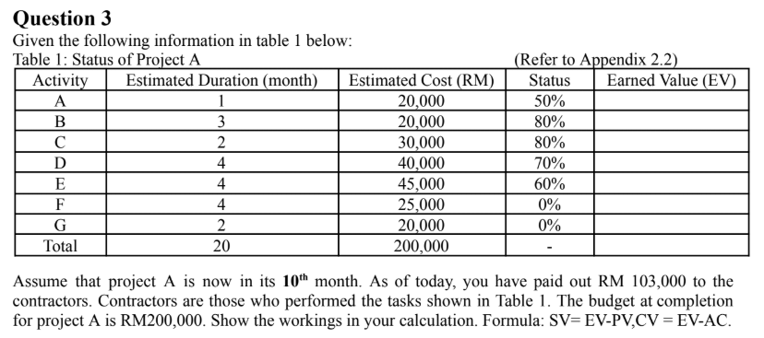

Activity | Estimated Duration (month) | Estimated Cost (RM) | Status | Earned Value (EV)
A | 1 | 20,000 | 50%
B | 3 | 20,000 | 80%
C | 2 | 30,000 | 80%
D | 4 | 40,000 | 70%
E | 4 | 45,000 | 60%
F | 4 | 25,000 | 0%
G | 2 | 20,000 | 0%
Total | 20 | it 200,000 | -

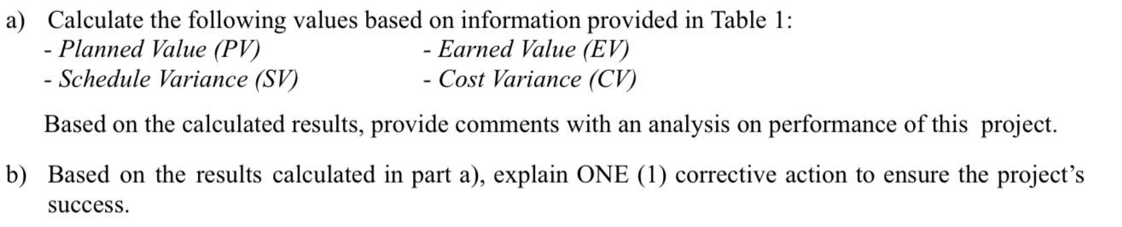

Team 1
a)
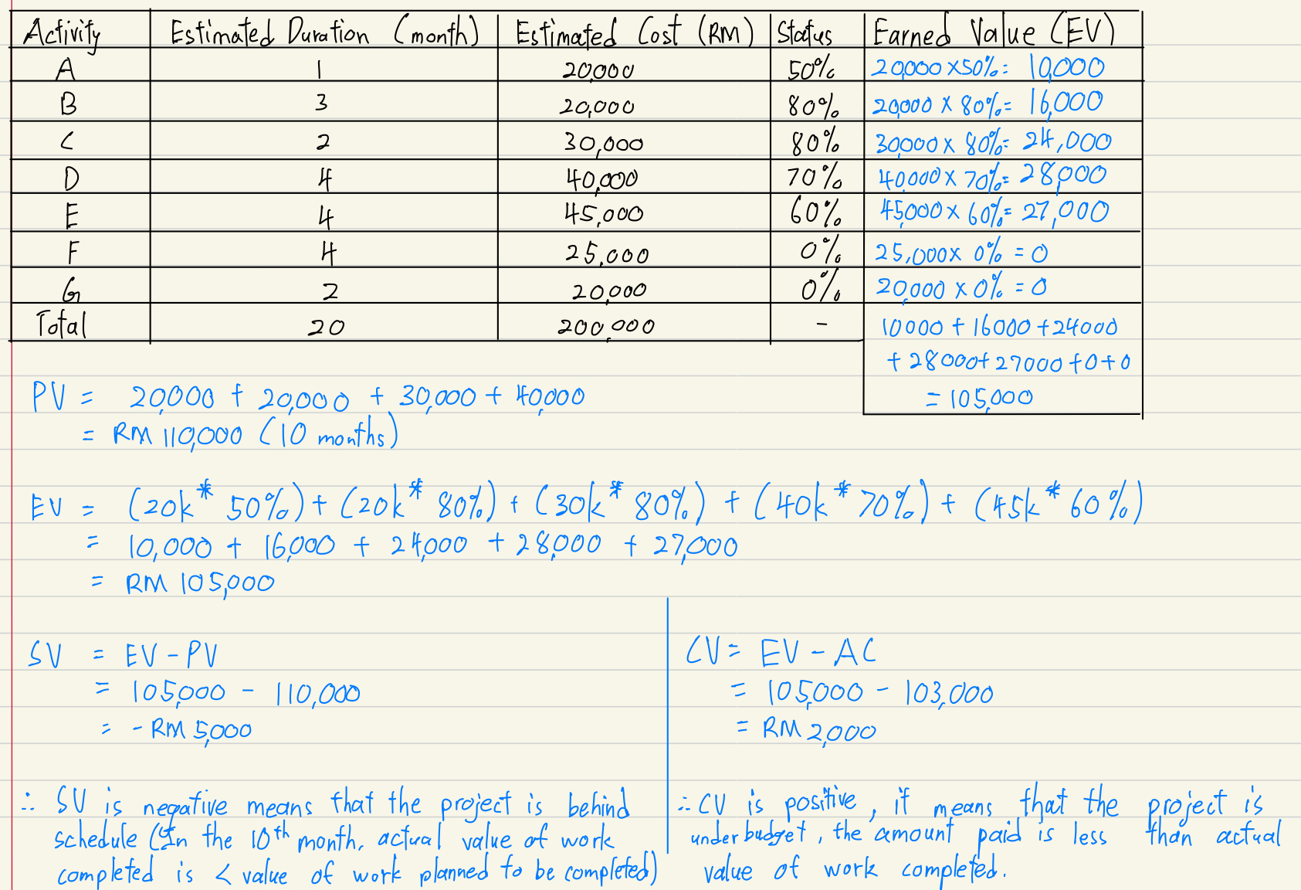

b)
adding more staff
Explanation:
When the Schedule Variance (SV) is negative, it means the project is behind schedule — the amount of work completed so far is less than what was planned.
By adding more staff, the project team gains additional workforce, allowing more tasks to be performed in parallel or speeding up delayed activities. This helps to accelerate progress and bring the project back on track.
Example:
If coding is behind schedule due to insufficient developers, assigning two more programmers can help finish modules faster and close the schedule gap.

Team 2
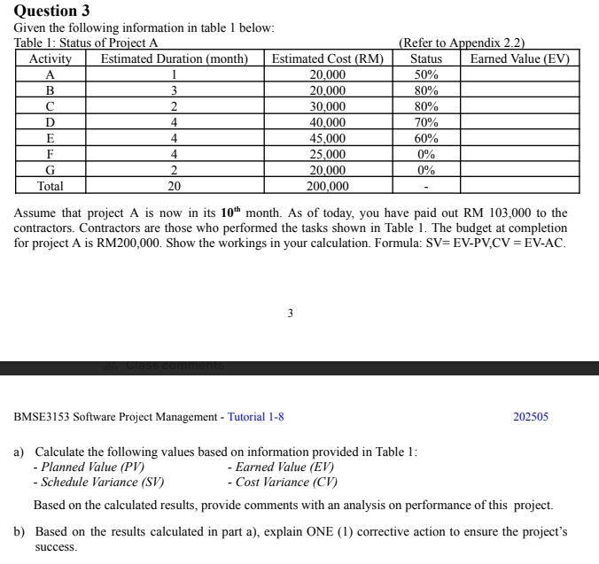
a)

Activity | Estimated Duration (month) | Estimated Cost (RM) | Status | Earned Value (EV)
A | 1 | 20,000 | 50% | 20,000 * 50% = 10,000
B | 3 | 20,000 | 80% | 20,000 * 80% = 16,000
C | 2 | 30,000 | 80% | 30,000 * 80% = 24,000
D | 4 | 40,000 | 70% | 40,000 * 70% = 28,000
E | 4 | 45,000 | 60% | 45,000 * 60% = 27,000
F | 4 | 25,000 | 0% | 25,000 * 0% = 0
G | 2 | 20,000 | 0% | 20,000 * 0% = 0
Total | 20 | 200,000 | - | 10,000 + 16,000 + 24,000 + 28,000 + 27,000 + 0 + 0 = RM 105,000

PV
Activity A+B+C+D =10 months
= 20,000 + 20,000 +30,000 + 40,000
= RM 110,000

AC = RM 103,000

EV = 10,000 + 16,000 + 24,000 + 28,000 + 27,000
= RM 105,000

SV = EV - PV
= 105,000 - 110,000
= RM -5,000 (negative behind schedule)

CV = EV - AC
= 105,000 - 103,000
= RM 2,000 (under budget)

- SV is negative (-RM 5000) means that the project is behind schedule (In the 10th month, the actual value of work completed is less than the value of work planned to be completed)

- CV is positive ( RM2000), which means that the project is under budget. In the 10th month, the actual value of work completed is more than the amount paid

b) Adding More Staff
- Adding more personnel can help complete the tasks faster, especially if the project is behind schedule due to a lack of resources. By increasing the workforce, the tasks can be handled simultaneously by more people, accelerating progress.
Team 3
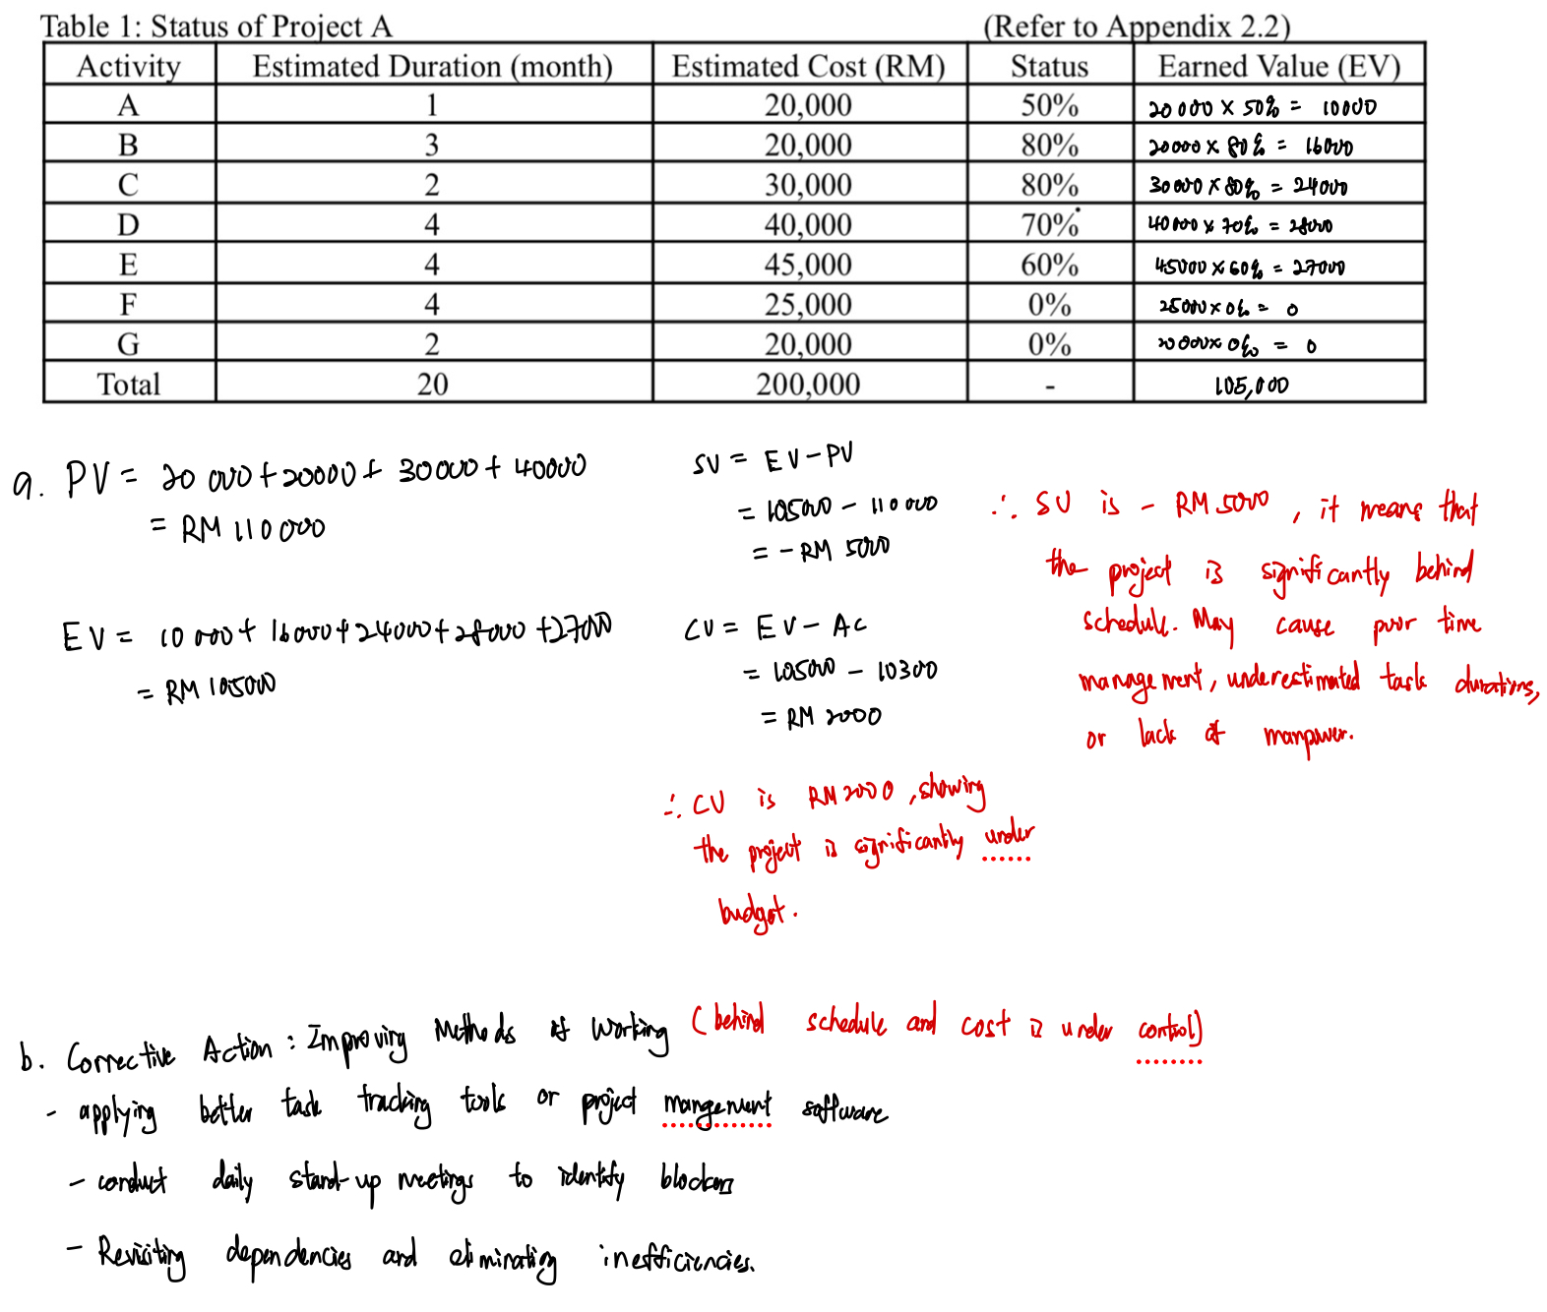

Team 4

Activity | Estimated Duration (month) | Estimated Cost (RM) | Status | Earned Value (EV)
A | 1 | 20,000 | 50% | 20,000 * 0.5 = 10,000
B | 3 | 20,000 | 80% | 20,000 * 0.8 = 16,000
C | 2 | 30,000 | 80% | 30,000 * 0.8 = 24,000
D | 4 | 40,000 | 70% | 40,000 * 0.7 = 28,000
E | 4 | 45,000 | 60% | 45,000 * 0.6 = 27,000
F | 4 | 25,000 | 0% | 25,000 * 0.0 = 0
G | 2 | 20,000 | 0% | 20,000 * 0.0 = 0
Total | 20 | 200,000 | - | 105,000

PV = 40,000 + 30,000 + 20,000 + 20,000 = 110,000
EV = 10,000 + 16,000 + 24,000 + 28,000 + 27,000 + 0 + 0 = 105,000
SV = EV - PV = 105,000 - 110,000 = -5,000
CV = EV - AV = 105,000 - 55,000 = -50,000

Question 4

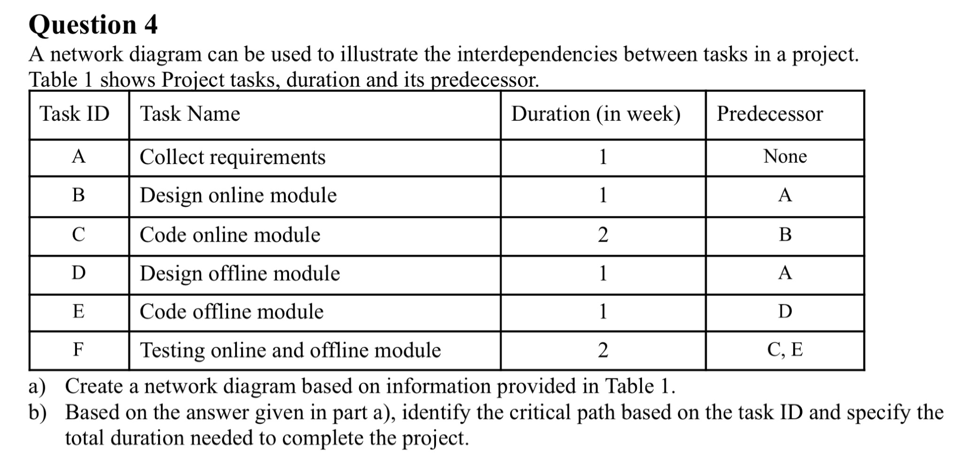
Team 1
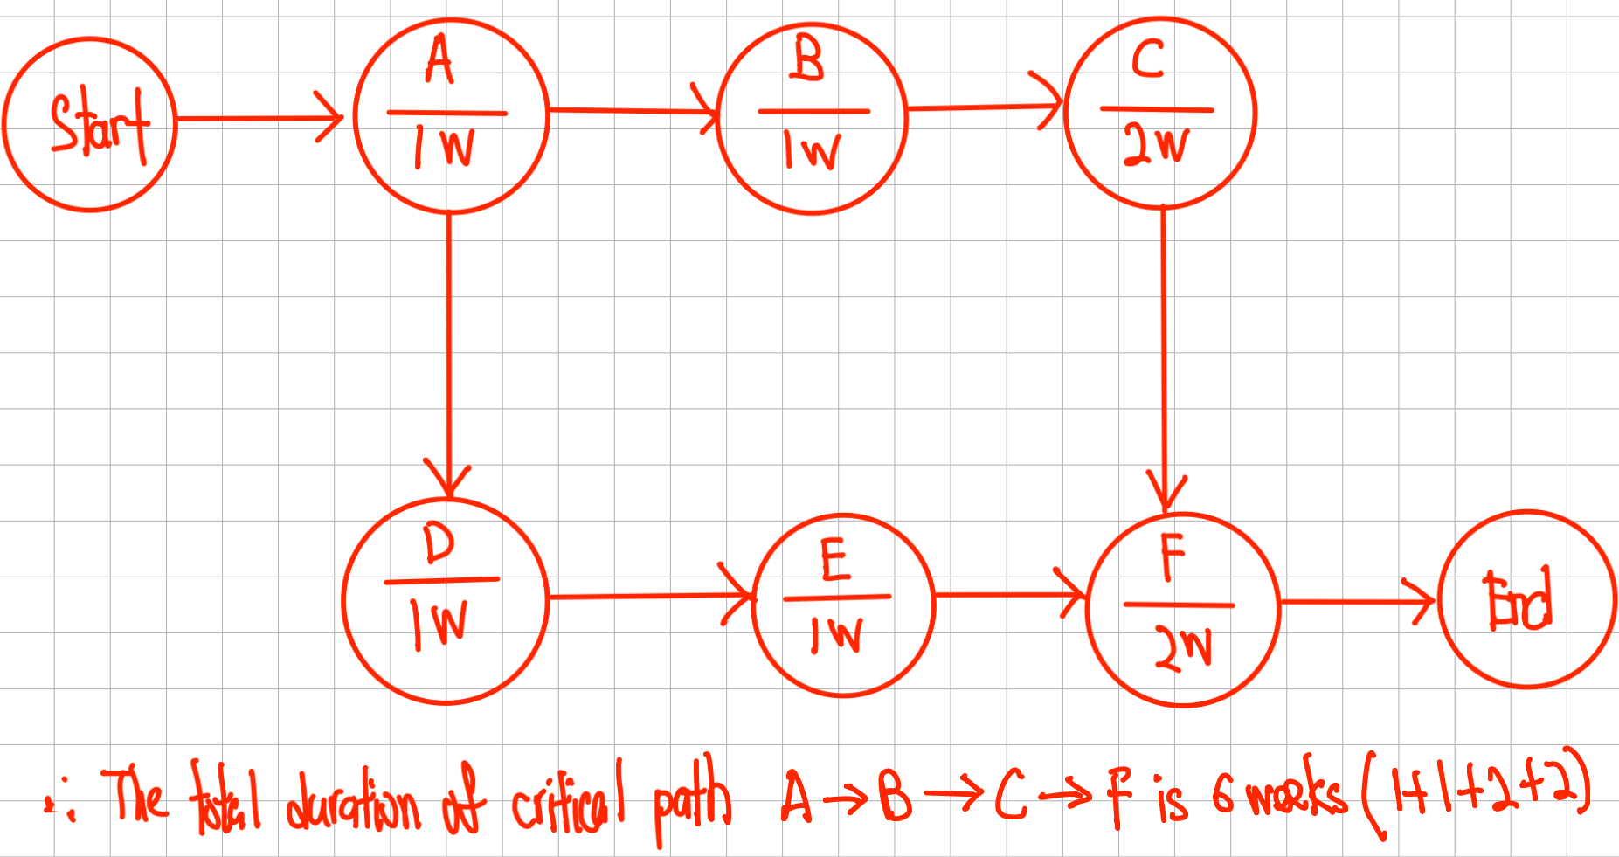
Team 2
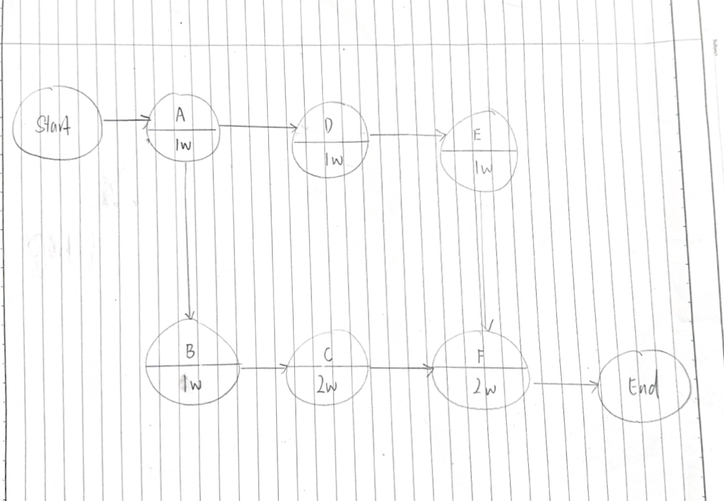
A → B → C → F
= 1 + 1 + 2 + 2 = 6 weeks
The critical path is the one with the longest duration, which is:
Critical Path: A → B → C → F
Total Project Duration: 6 weeks

Team3
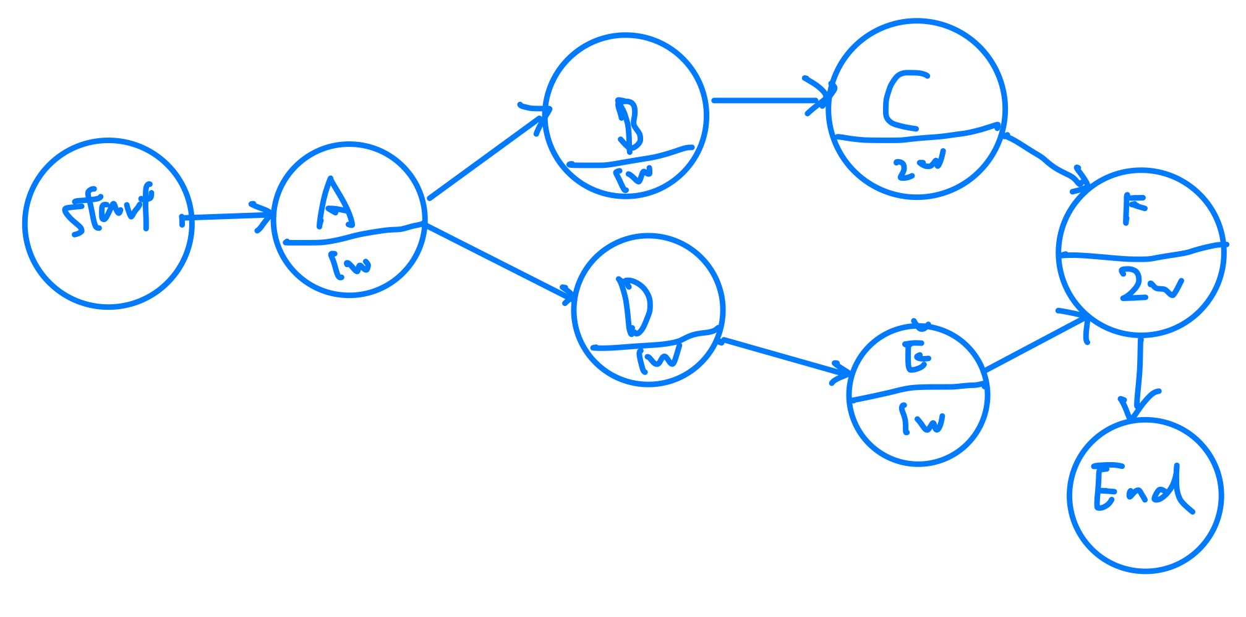
The total duration of critical path A -> B ->C ->F is 6 week (1w+1w+2w+2w=6w)
Team 3 (Tan)
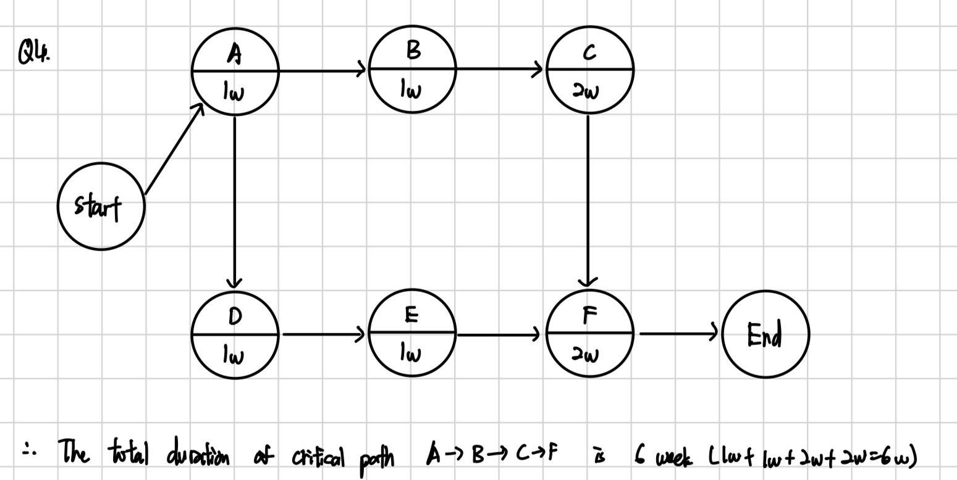

Team 4

Question 5 (Team 1)
Gantt charts are used to illustrate the sequence of activities in a project. Figure 1 is an example of a Gantt chart. Redraw the Gantt chart in Figure 1 using the predecessor information provided in Table 1 to illustrate the interdependencies between project activities. Assuming the project starts in June 2024.
Figure 1: Example of a Gantt chart
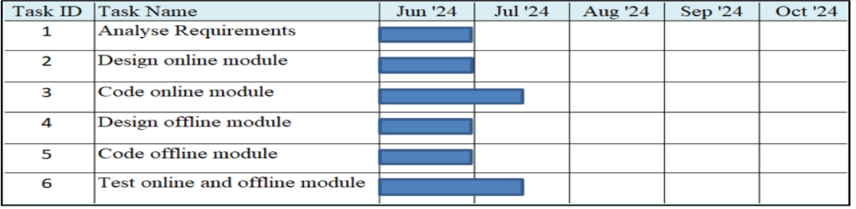

Table 1: Project activity and its predecessor
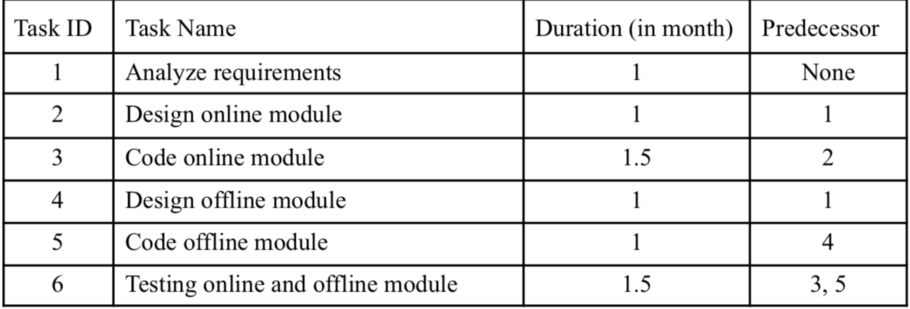

Identify the month for the task ID 6 will be completed.

Team 2
Answer:
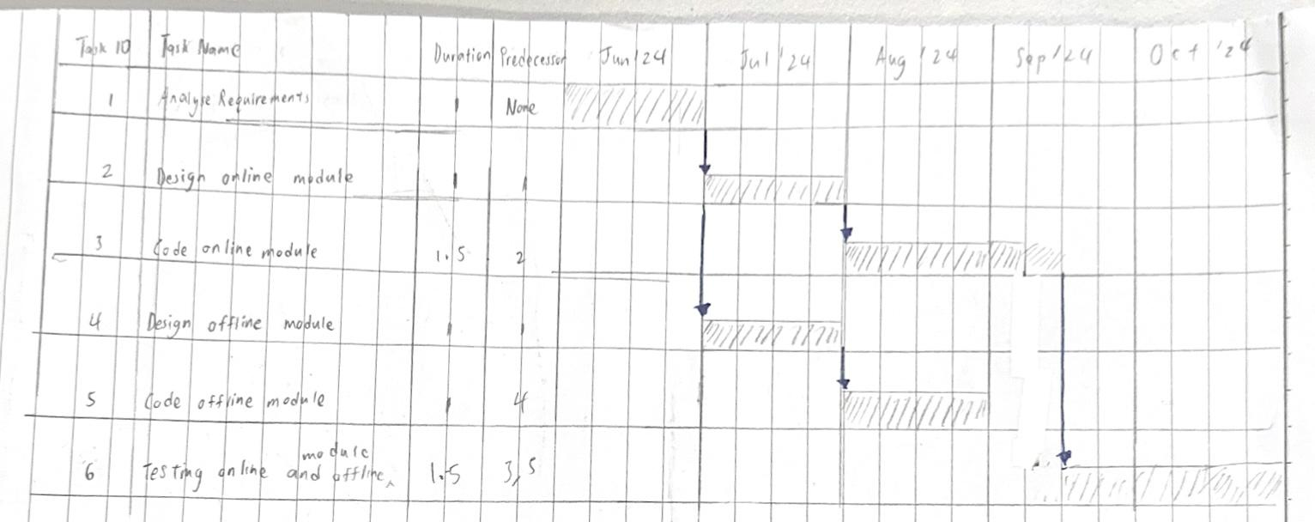

The month for task ID 6 will be completed at the end of October.

Answer:

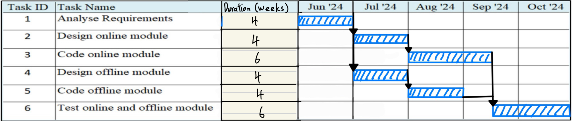

The month for task ID 6 will be completed at End of October.

Q5 Team 3

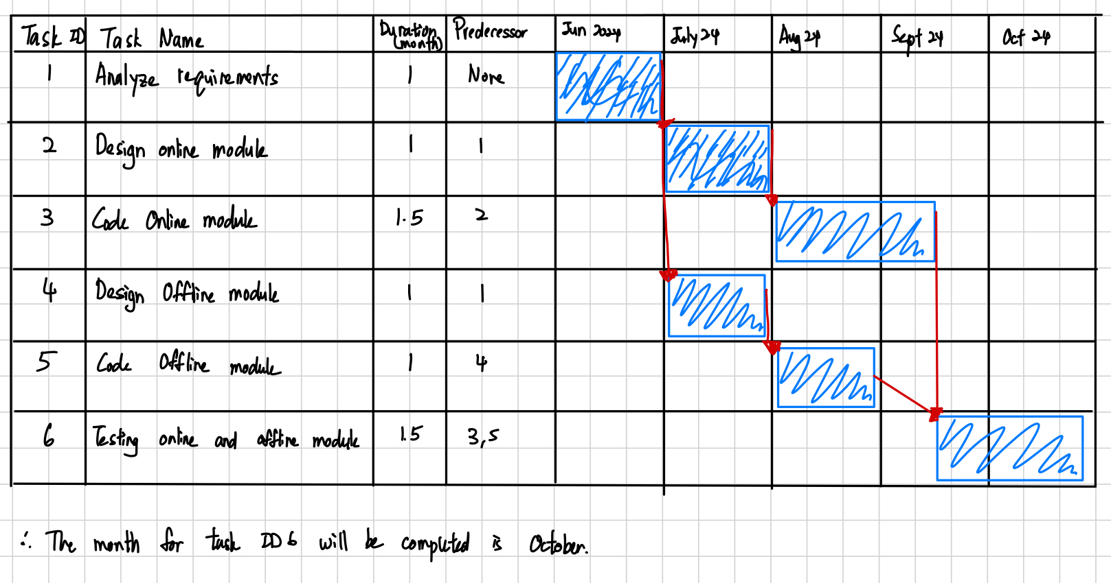

Q5 Team 5
